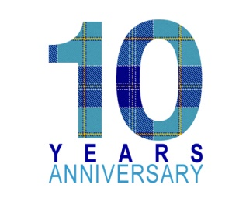

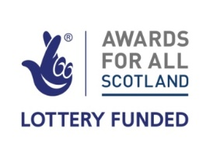

**DHS 10th Anniversary Celebrations**

**Saturday 13th October 2018**

at Deaf Connections, 100 Norfolk Street, Glasgow

**ORDER FORM**

|  |  |  |
| --- | --- | --- |
|  | **How many** | **Total** |
| **Lunch £5 per person** |  |  |
| **Dinner £20 per member** |  |  |
| **Dinner £30 per non-member** |  |  |
|  | **GRAND TOTAL** |  |
| **Do you have a dietary requirement?** |  | |
| **Vegetarian** |  | |
| **Gluten free** |  | |
| **Other – please state** |  | |
| **Name** |  | |
| **Address** |  | |
| **Email address** |  | |
| **Please post this order form with a cheque payable to Deaf History Scotland to DHS, c/o Deaf Connections, 100 Norfolk Street, Glasgow G5 9EJ** | | |
| **Or pay via BACS: Account number 26400989 Sort Code 09-01-29** | | |
| **Deadline: Friday 5th October 2018** | | |